Architecture

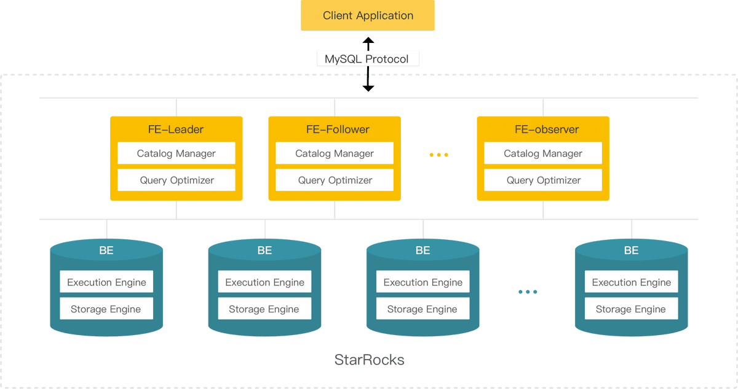

- FE(Frontend): The StarRocks frontend node is responsible for metadata management, management of client connectors, query planning, query scheduling, and so on.
- BE(Backend): The StarRocks backend node is responsible for data storage, calculation execution, compaction, replication management, and so on.
- Broker: A transit service that connects external data such as HDFS and object storage, assisting import and export functions.
- Tablet: The logical sharding of a StarRocks table, as well as the basic unit of copy management. Each table is divided into multiple tablets and stored on different BE nodes according to the partitioning and bucketing mechanisms.
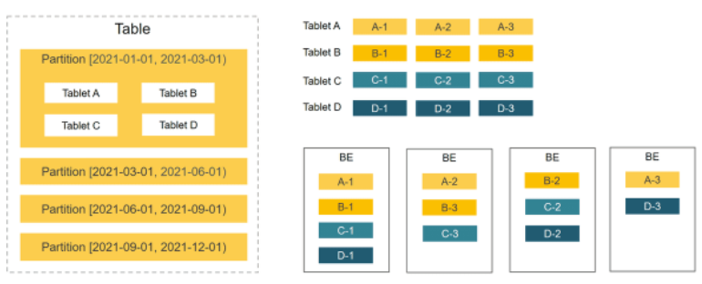

Doris Version

StarRocks is based on Apache Doris. And it has implemented native vectorized engine, which leads to better performance.
It also has CBO (Cost Based Optimizer), which can give a better plan for complex query

- Apache Doris : 1.0.0 (1.1.0-preview2 build by myself)
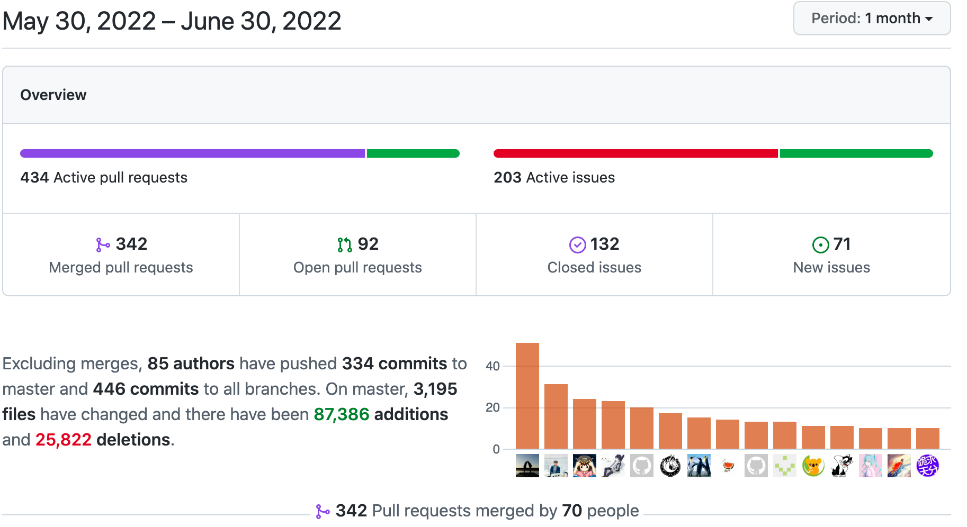

Portal http://doris-fe-ha-svc.oss-prod-ns.svc.57.tess.io/
Tess https://cloud.ebay.com/object/detail/StatefulSet:doris-be:57:oss-prod-ns/summary

- StarRocks: 2.3.0 (2.2.1)

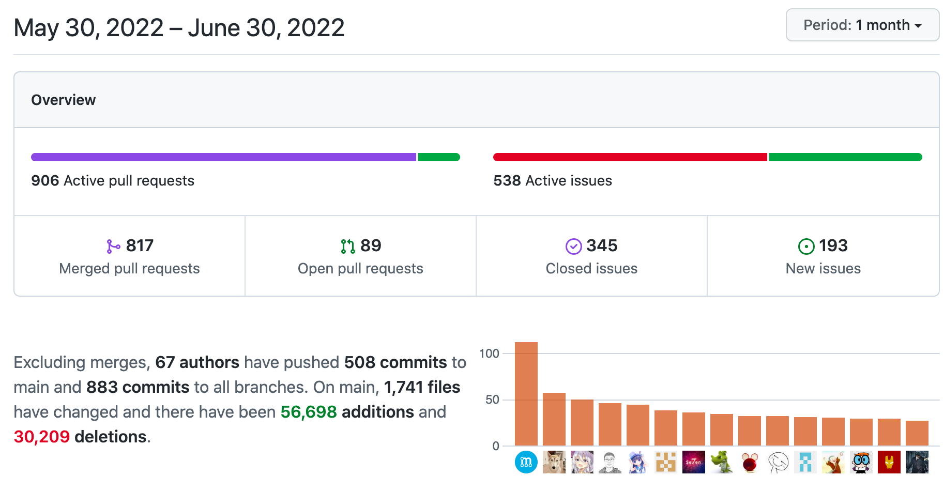

Portal http://doris.gro-prod-ns.svc.57.tess.io
Tess https://cloud.ebay.com/object/detail/StatefulSet:doris-be:57:gro-prod-ns/summary

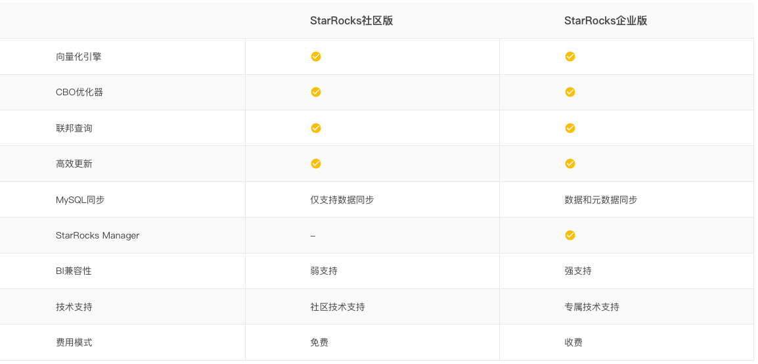
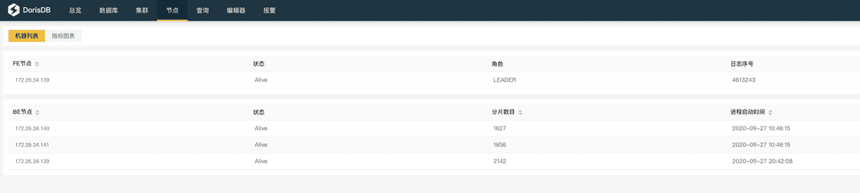
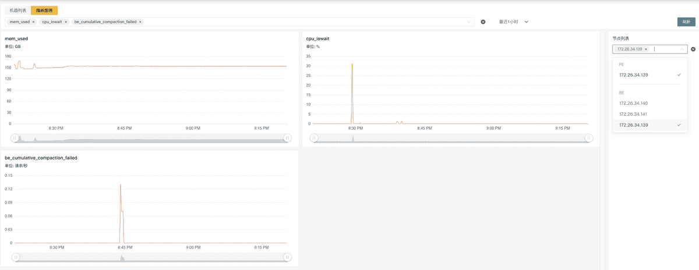

Introduction

Data Model

Features | Applied Scenarios
Duplicate model | It is used to save and analyze the original detailed data, with additional writing as the main method, while offers almost no update after the data is written. | Logs, operation records, equipment status sampling, time series data, etc.
Aggregate Model | Used to save and analyze summaries (such as max, min, sum, etc.) without querying detailed data. After the data is imported, the aggregation is completed in real time, and there is almost no update after the data is written. | Summarize data by time, region, organization, etc.
Primary Key Model | Supports updates based on primary keys, delete-and-insert, and guarantees high-performance queries when importing in large quantities. Used to save and analyze data that needs to be updated. | Orders whose status will change,such as equipment status, etc.
Unique Model | Support update based on primary key, Merge On Read, update frequency is higher than primary key model. Used to save and analyze data that needs to be updated. | Orders whose status will change,such as equipment status, etc.

Summary

Benchmark
- Env resource
- Star-Schema
- TPC-H
- GRO lstg
  - StarRocks vs CK
  - 16c vs 12c
  - Materialized
- Ads
  - SSD vs HDD
YAML in Tess
- metadata:
name: data1
spec:
accessModes:
- "ReadWriteOnce"
resources:
requests:
storage: "200Gi"
storageClassName: "local-dynamic"
- metadata:
name: data2
spec:
accessModes:
- "ReadWriteOnce"
resources:
requests:
storage: "20Gi"
storageClassName: "cinder-standard"
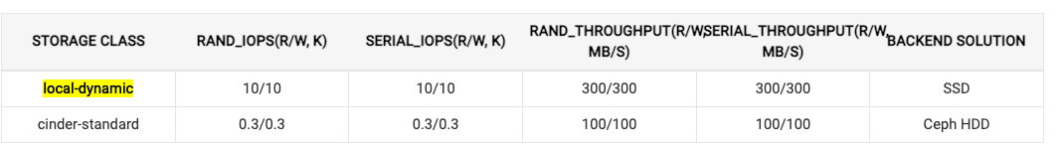

Materialized View

GRO Lstg test Normal vs Materialized
 |  | StarRocks Duplicate Key model iter=10
 |  | concurrency=1 |  |  | concurrency=5 |  |  | concurrency=10
 |  | avg | min | max | avg | min | max | avg | min | max
q4 | normal | 1.436 | 1.416 | 1.482 | 7.148 | 7.09 | 7.245 | 14.239 | 14.173 | 14.371
 | materialized | 0.362 | 0.331 | 0.501 | 1.697 | 1.677 | 1.709 | 3.389 | 3.31 | 3.409
q5 | normal | 1.46 | 1.428 | 1.498 | 7.19 | 7.118 | 7.242 | 14.279 | 14.073 | 14.464
 | materialized | 0.323 | 0.313 | 0.335 | 1.695 | 1.668 | 1.725 | 3.339 | 3.216 | 3.399

Materialized CPU/Memory/Network Cost
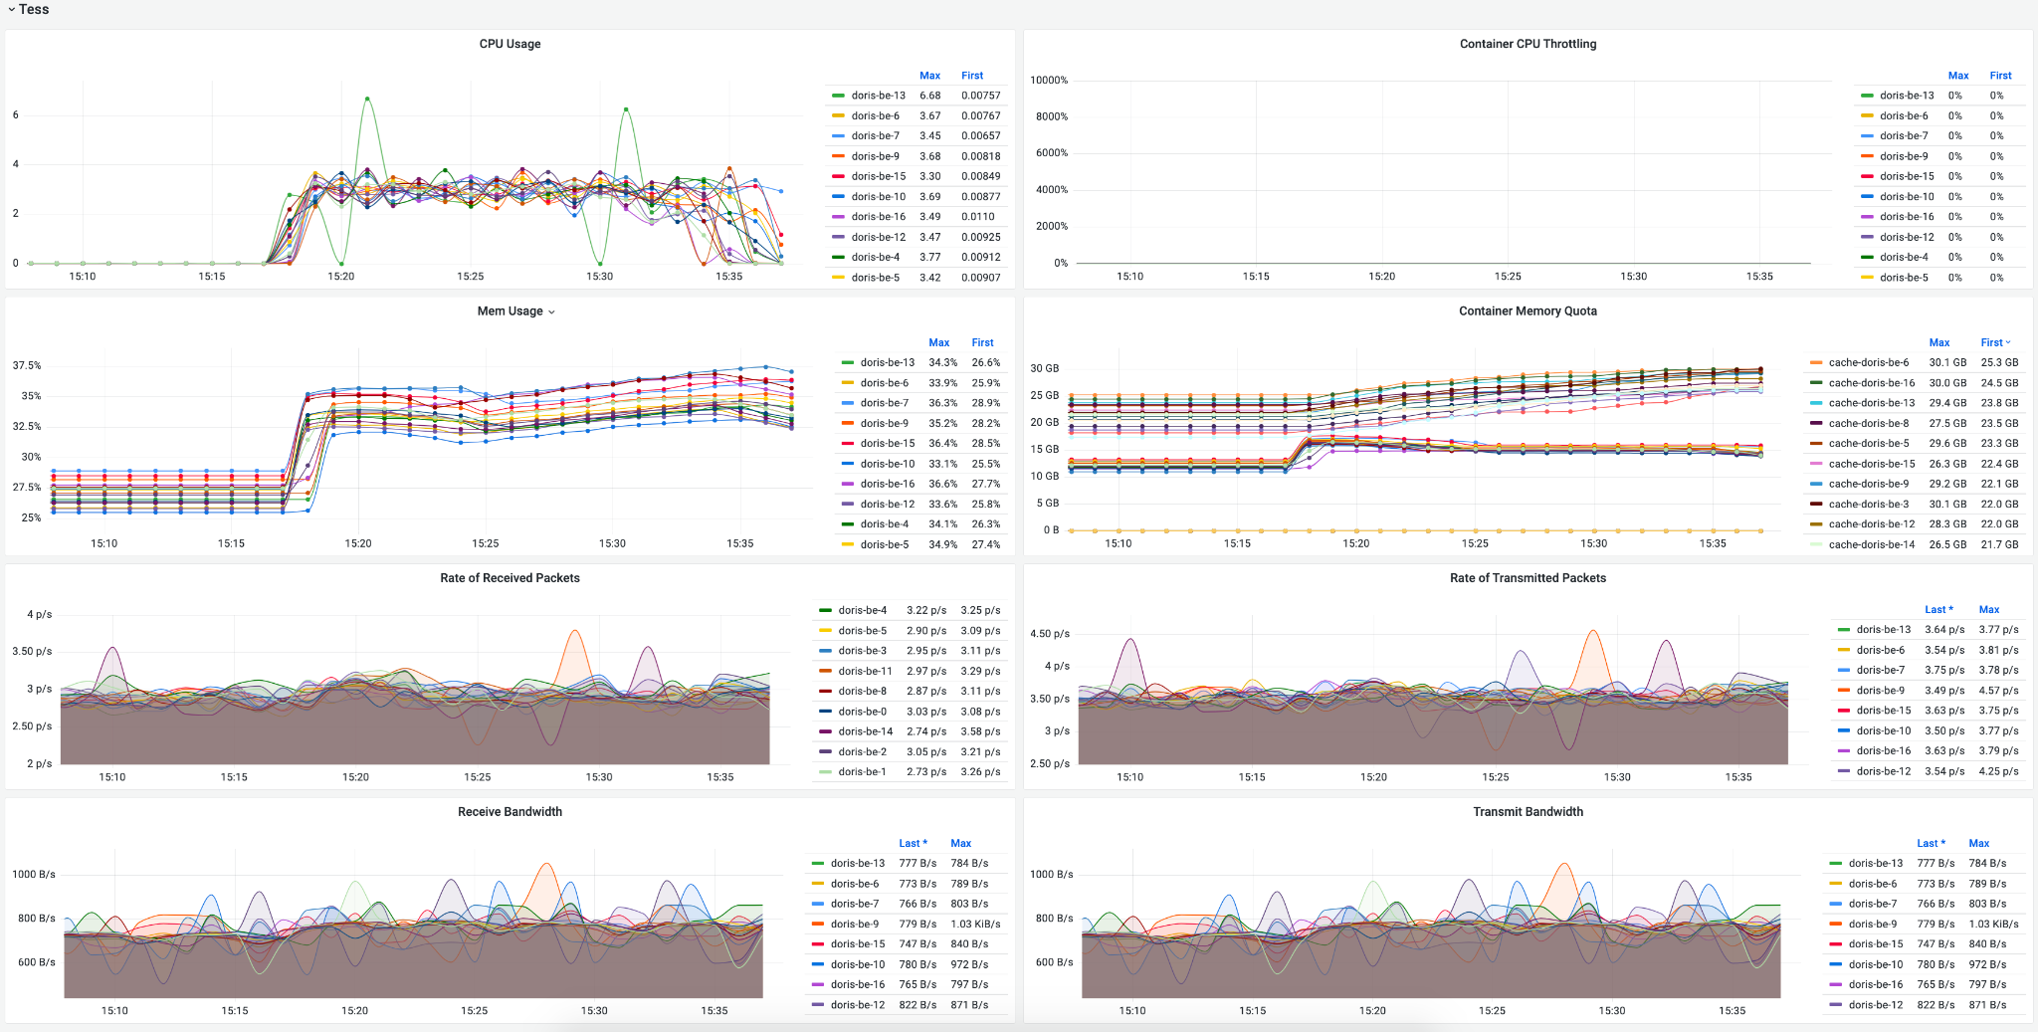

Limitation
- The aggregation function of materialized views only supports a single column as an argument, for example: sum(a+b) is not supported.
- If the condition column of a delete statement does not exist in the materialized view, the delete operation cannot be performed. If you must delete the data, you need to delete the materialized view first .
- Too many materialized views on a single table affects import efficiency. When importing data, the materialized view and the base table data are updated simultaneously. Therefore, if there are more than 10 materialized views on a table, the import speed may be slow (it’s like importing 10 tables at the same time).
- Same column with different aggregation functions can not appear in a materialized view at the same time, for example: select sum(a), min(a) from table is not supported.
- The creation statement of materialized views currently does not support JOIN, WHERE,VIEW, or the HAVING clause of GROUP BY/ORDER BY.
- You cannot create more than one materialized view at the same time. You can only create a new materialized view after the previous creation is complete

High cardinality columns (slr_id,...)
Even worse in materialized view, cluster will down seconds by bad Query
bpe_v.pl_elgbl_slr_mtrc_sd
Details Count：
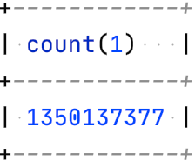
materialized view Aggregate Count:
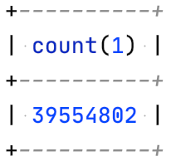
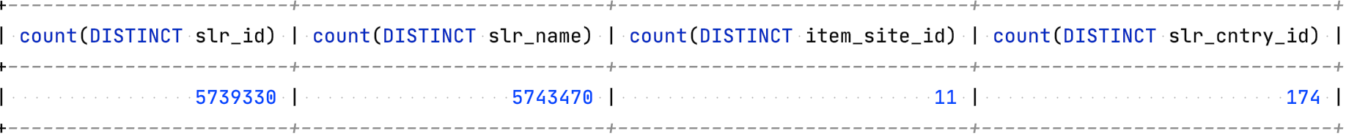
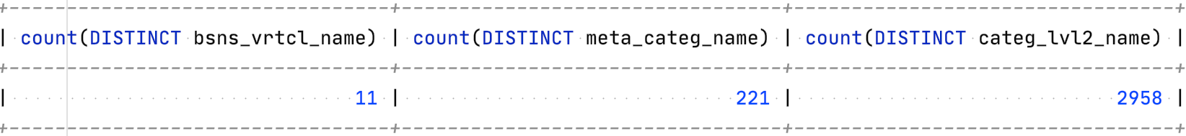
SELECT slr_id
,slr_name
,item_site_id
,slr_cntry_id
,bsns_vrtcl_name
,meta_categ_name
,categ_lvl2_name
,sum(pl_lstg_cnt)
,sum(pl_gmv_usd_amt)
,count(distinct cal_dt)
FROM bpe_v.pl_elgbl_slr_mtrc_sd
GROUP BY slr_id,
slr_name,
item_site_id,
slr_cntry_id,
bsns_vrtcl_name,
meta_categ_name,
categ_lvl2_name
order by sum(pl_gmv_usd_amt) desc
LIMIT 20
;

ERROR 1064 (HY000): Memory of Querye7f79641-fa16-11ec-b4f5-96edb0433652 exceed limit. Used: 21469503892, Limit: 21474836480. Mem usage has exceed the limit of single query, You can change the limit by set session variable exec_mem_limit.
SELECT slr_id
,slr_name
,item_site_id
,slr_cntry_id
,bsns_vrtcl_name
,meta_categ_name
,categ_lvl2_name
,sum(pl_lstg_cnt)
,sum(pl_gmv_usd_amt)
,count(distinct cal_dt_int)
FROM bpe_v.pl_elgbl_slr_mtrc_sd_v2
GROUP BY slr_id,
slr_name,
item_site_id,
slr_cntry_id,
bsns_vrtcl_name,
meta_categ_name,
categ_lvl2_name
order by sum(pl_gmv_usd_amt) desc
LIMIT 20
;
ERROR 1064 (HY000): Memory of Query50fc7ad1-fcd5-11ec-b4f5-96edb0433652 exceed limit. Pipeline Backend: 10.174.72.201, fragment: 50fc7ad1-fcd5-11ec-b4f5-96edb04336a2 Used: 21476242328, Limit: 21474836480. Mem usage has exceed the limit of single query, You can change the limit by set session variable exec_mem_limit.
mysql> SHOW VARIABLES like "%exec_mem_limit%";
+----------------------+-----------------+
| Variable_name | Value |
+----------------------+-----------------+
| exec_mem_limit | 2147483648 |
+----------------------+-----------------+
1 row in set (0.01 sec)

mysql> set global exec_mem_limit = 8589934592;
Query OK, 0 rows affected (0.00 sec)

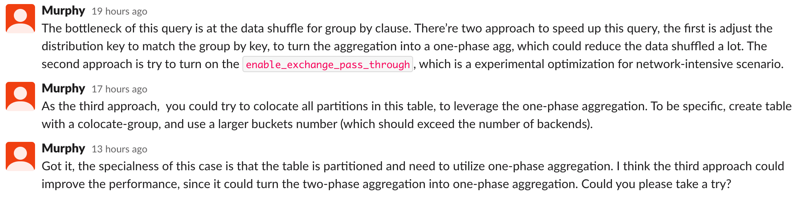
20 rows in set (27.07 sec) (materialized)
20 rows in set (25.15 sec) (DUPLICATE model)
20 rows in set (19.75 sec) (enable_exchange_pass_through)

How to solve it?
Collect bad query find pattern, and add it in blacklist

GRO LSTG dist usage
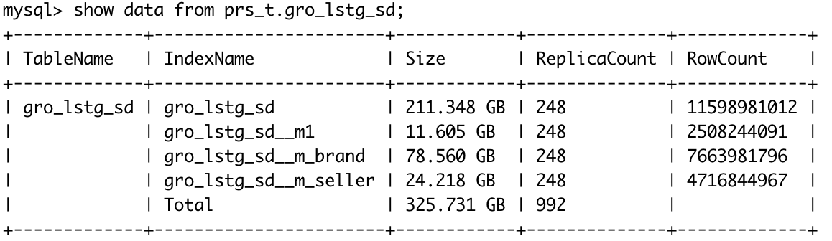
SSD/HHD
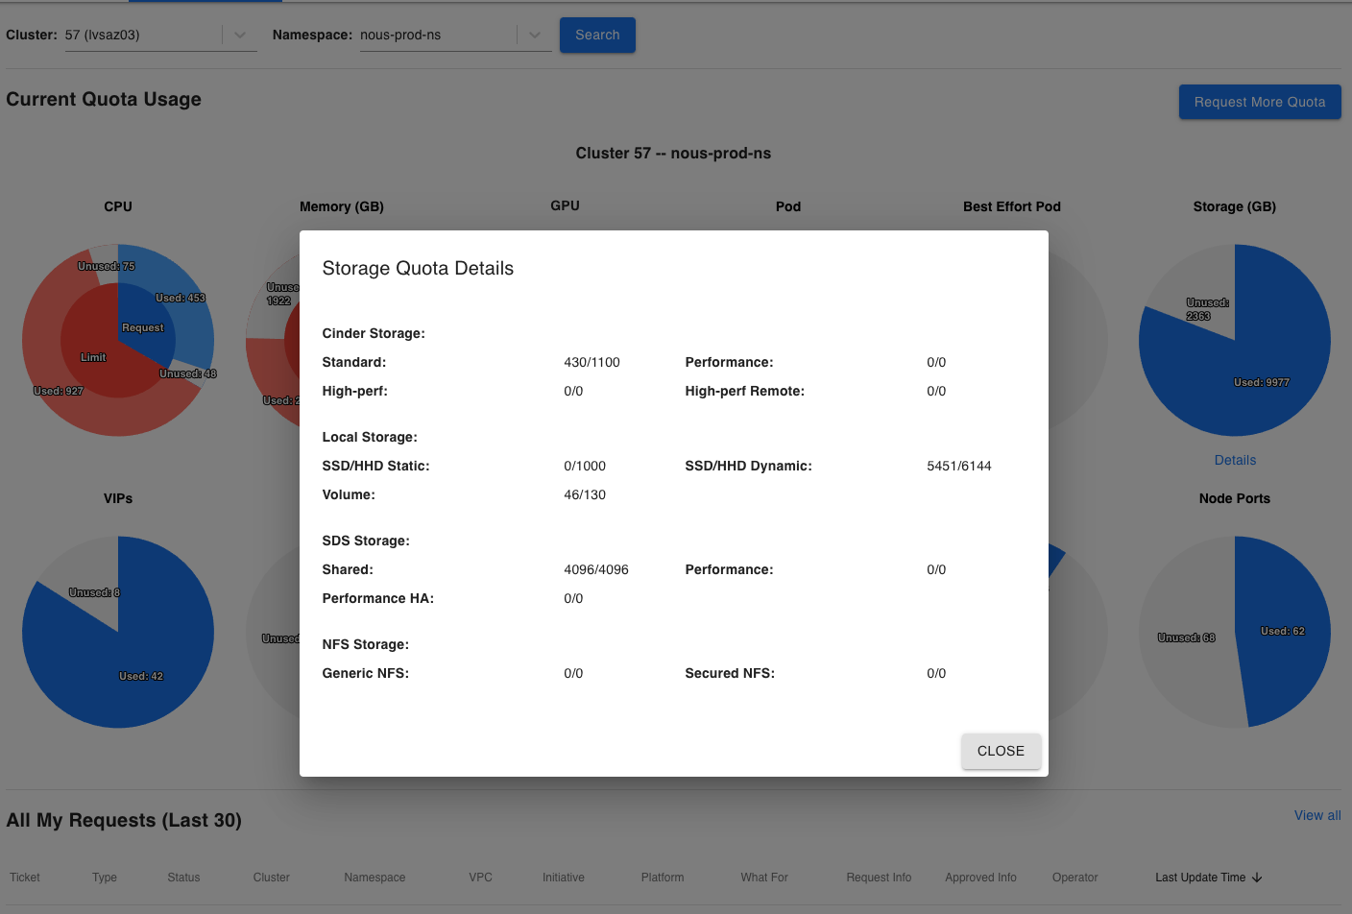

[Preview] Resource group
 | Ads q6
 | concurrency=1 |  |  | concurrency=5 |  |  | concurrency=10
resource | avg | min | max | avg | min | max | avg | min | max
all | 0.699 | 0.67 | 0.75 | 3.631 | 3.558 | 3.714 | 7.509 | 7.456 | 7.591
1/3 | 1.381 | 1.223 | 1.451 | 10.003 | 4.653 | 13.746 | 24.628 | 16.783 | 28.326
 | 1.98 |  |  | 2.75 |  |  | 3.28
 | GRO lstg q7
 | concurrency=1 |  |  | concurrency=5 |  |  | concurrency=10
resource | avg | min | max | avg | min | max | avg | min | max
all | 0.887 | 0.833 | 0.968 | 4.21 | 4.158 | 4.268 | 8.268 | 8.163 | 8.416
2/3 | 1.329 | 0.873 | 1.494 | 6.358 | 5.434 | 11.309 | 14.532 | 13.483 | 16.065
 | 1.50 |  |  | 1.51 |  |  | 1.76

Clickhouse Q7(CPU resources are close to StarRocks):
gro_lstg_sd | gro_lstg_sd_v2 | gro_lstg_sd_v3 | gro_lstg_sd_v4
8.594 | 4.512 | 1.277 | 4.895

Manage a cluster
- Import Data
  - Stream Load, http load, git code
gro lstg data
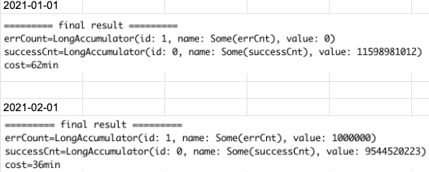
  - Spark Load, for big data
  - Broker Load, use MySQL protocol (hundred GB)
  - Routine Load, for Kafka

- Monitor in Prometheus, the template provided by the official website cannot be used directly, and the metrics are not clear yet.
- bad/slow SQL should be monitored, blacklist(not suitable for all case)
  - If the concurrency is not high, there is no need to materialize currently, materialization is what we do and has nothing to do with the customer
- Currently, we could have simply generated a StarRocks table from a Hadoop table
- IP change problem, cluster reinstall because of Shepard stop the cluster ip changed.
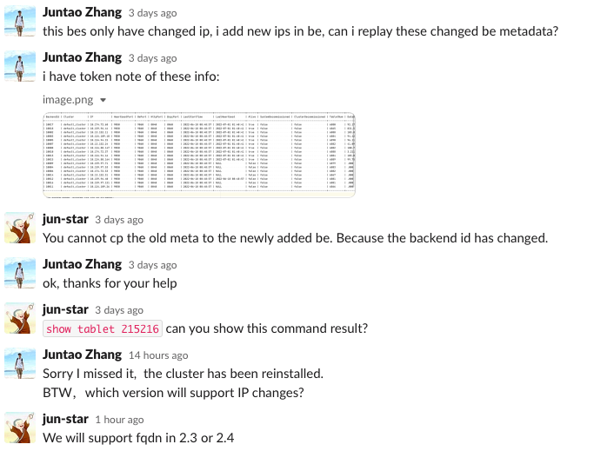
  - next version helped by community
  - Create jira to fixed ip for Tess team

Proposal integrate with NOUS
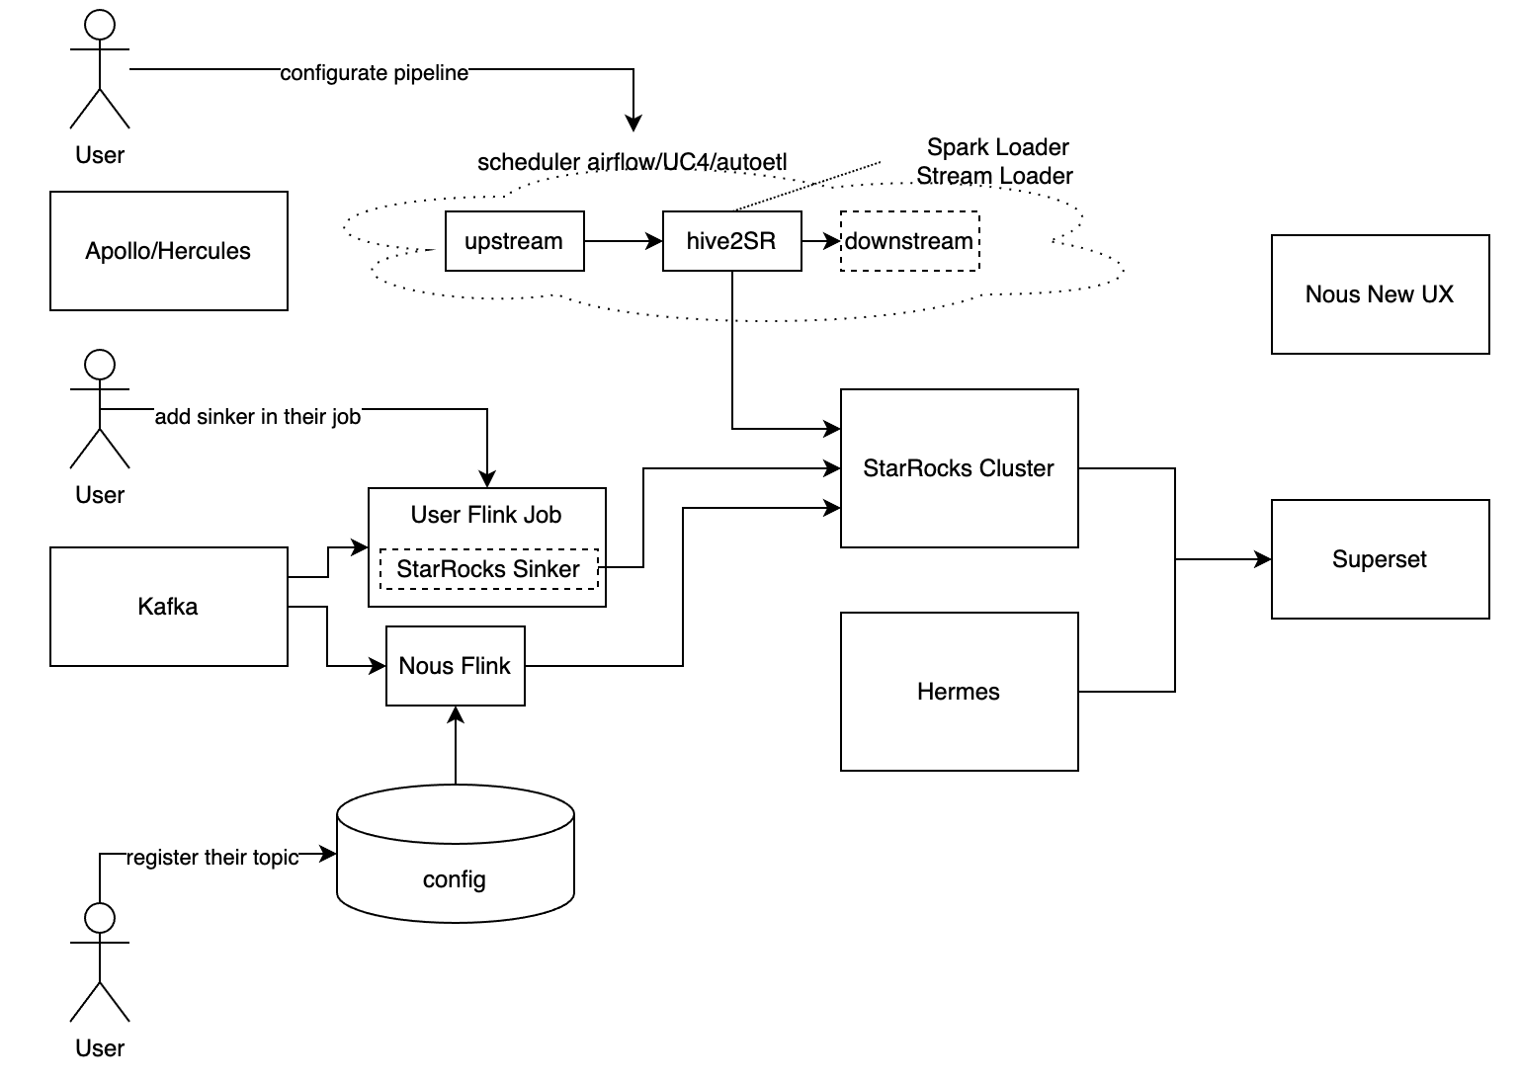

Other Team(PA)
- Import Data Performance
use Stream Load
- StarRocks VS Kylin

TODO
- Test Spark Load/Broker Load
- Streaming to StarRocks
- Test Custom UDF
- Bad/Slow Query monitor, Blacklist
- Cluster Monitor(IP Change problem)
- Test federation query, like es/mysql

